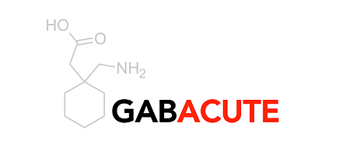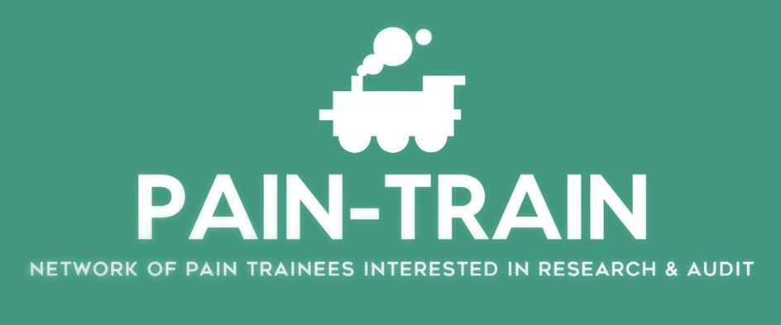

Certificate of participation

GABACUTE

December 2017

**The Project:**

The GABACUTE study was a snapshot national observational study run nationally by the PAIN-TRAIN anaesthetic trainee network. It aimed to assess gabapentinoid prescribing and attitudes amongst anaesthetists. Drug charts for all adult (non-obstetric) patients undergoing elective or emergency surgery within the data collection period were assessed for perioperative gabapentinoid prescribing. A survey was carried out to elucidate the beliefs and attitudes of all anaesthetists surrounding the gabapentinoid safety, efficacy, short and longer term benefits. The study ran for two days during week commencing 4th December 2017.

**The Results:**

Data has been sent to the study organisers. Full results are awaited.

Consultant support by:

Pete Claydon

Donald Graham

Tom Bendinger

Trainee support by:

Martyna Berwertz (Trainee lead)

Joel Perfitt

Kimberley Newton

Tom Kingston

Aaqid Akram

Yaruk Shifa

Richard Harrold

Rebecca Hawes

SHARC:

Claire Hirst (SHARC lead)

Daniel Yarwood

Becky Morris

Tim Orr

Mark Prince

James Briscoe

# The project team: